Pizza Sales Project Sql Queries
A.KPI’s
1.Total Revenue
select SUM(total_price) as Total_Rev from pizza_sales
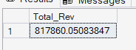
2. Avg Value
select sum(total_price) / count(distinct order_id) as Avg_order_value from pizza_sales;
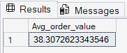
3.Total Pizza Sold
select sum(quantity) as Total_Pizza_sold from pizza_sales;
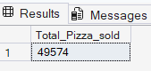
4.Total Order Count
select count(distinct order_id) as Count_order_value from pizza_sales;
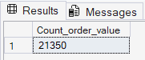
5.Avg Pizza Per Order
select cast(sum(quantity)/count(distinct order_id) as decimal(10,2)) as Avg_pizza_per_order from pizza_sales;
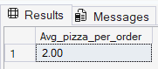

Sql Queries
1.Daily Trend
select DATENAME(dw, order_date) as order_day,
count(distinct order_id)as total_orders
from pizza_sales
group by DATENAME(dw, order_date)
order by DATENAME(dw, order_date) asc;
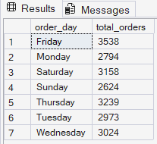
2.Hourly Trend
select DATEPART(hour, order_time) as order_hours,
count(distinct order_id) as total_orders
from pizza_sales
group by DATEPART(hour, order_time)
order by DATEPART(hour, order_time);
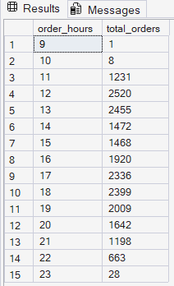
3.Percentage sales by pizza category
select pizza_category, sum(total_price)*100/
(select sum(total_price) from pizza_sales where MONTH(order_date)=1) as PCT
from pizza_sales
where MONTH(order_date)=1
group by pizza_category;
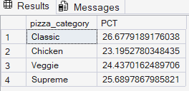
4. total pizza sold by pizza category
select pizza_category, sum(quantity) as total_sold_pizza
from pizza_sales
group by pizza_category;
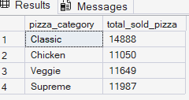
5. top 5 pizza sold by pizza name
select top 10 pizza_name, sum(quantity) as top_5_pizza_sold
from pizza_sales
group by pizza_name
order by sum(quantity) desc
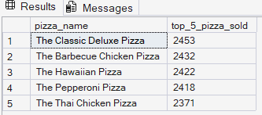
6. top 5 pizza sold by month(may)
select top 10 pizza_name, sum(quantity) as top_5_pizza_sold
from pizza_sales
where month(order_date)=5
group by pizza_name
order by sum(quantity)
